The Sensory Systems
What are the 5 senses and their sensory organs?  What are the different sensory receptors and what do they detect?  What is referred pain?  Why are smell and taste “chemical senses”?  What do tastebuds contain?  What contains chemoreceptors for smell?  What are the 3 parts of the ear?  Describe the significance of the eardrum?  What are the ossicles?  Describe the cochlea.  How do we hear?  Describe the process of hearing.  How is equilibrium maintained?  Describe each of the structures of the eye.  What do rods allow you to see?  What do cones allow you to see?  What does the lens do?  How does the pupil admit different amounts of light?  Trace the path of light through the structures of the eye.  What is accommodation?  Describe how the lens changes shape.  What are the two types of photo-receptor cells in the retina?  What does each allow you to see?  What is the blind spot?  Describe the optic chiasm and its significance.  Describe the differences between farsightedness and nearsightedness.  Why does each vision problem occur?  What happens to the eye with old age?  What is an astigmatism caused by?  What is color blindness and what causes it?  Why are more men color blind?  What is glaucoma?  What are cataracts? | Sense Organ  Touch Skin (external)  Taste Tongue  Smell Nose  Hearing/Equilibrium Ears  Sight Eyes  •The Sensory System  - The central nervous system receives information from the ____________ and ______________ environment via the sensory organs.  - Sensory organs are able to “sense” this information because of specialized ___________  - When a receptor is triggered, it causes an action potential in the sensory neuron.  •Types of Sensory Receptors  - 1. _____________________ – stimulated by changes in pressure or movement  - Found in skin and muscles  - 2. _____________________ – stimulated by changes in temperature  - Found in skin  - 3. _____________________ – stimulated by tissue damage  - Found in skin and viscera  - 4. _____________________ – stimulated by changes in chemical concentration of substances  - Used for taste and smell  - 5. _____________________ – stimulated by light  - Found only in the eye  •Sense of Touch  - Mechanoreceptors in the skin and viscera detect varying degrees of pressure.  - Free nerve endings have pain receptors and ____________________.  - Pain  - Pain is caused by _________________ released by inflamed tissues.  - Aspirin and ibuprofen reduce pain by blocking synthesis of these chemicals  - _______________________ – inside the body’s organs, pain is often felt in another area.  - Ex: Pain from the heart is felt in the left shoulder and arm  •Senses of Taste & Smell  - Taste and smell are “_______________ senses”  - Taste – ______________ containing ______________________ are found in the epithelium of the tongue  - ____________ (bumps) on the tongue contain many receptors  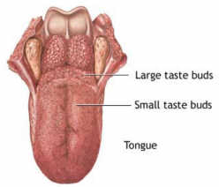  - Receptors on different parts of the tongue can distinguish between sweet (front), sour (back sides), salty (front sides), and bitter (back) tastes.  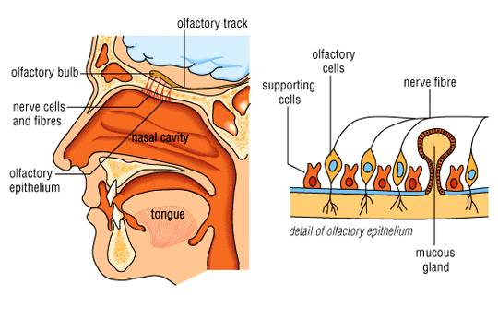  - Smell – within the nasal cavity, chemoreceptors in the _____________________ are stimulated by odor molecules  - Smells have been shown to be linked to ________________ because the olfactory bulb is linked to the limbic system of the brain.  •Sense of Hearing  •Anatomy of the Ear  - 1. Outer Ear – includes:  - _____________ (external ear)  - Auditory canal  - 2. Middle Ear- includes:  - ____________ (tympanic membrane)  - Ossicles – 3 small bones  - 1) __________ (hammer)  - 2) __________ (anvil)  - 3) __________ (stirrup)  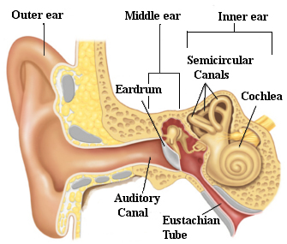  - Eustachian tube – equalization of air pressure (“pops” ear)  - 3. Inner Ear – includes:  - Semicircular canals – involved with equilibrium  - _______________ – snail-shaped structure involved with hearing  •How we Hear  –1. Sound waves travel through the ____________________ to the eardrum.  –2. The sound waves cause the _____________________________.  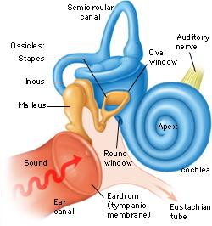  –3. The vibration causes the ____________ (hammer) to hit the ____________ (anvil) and then the ___________ (stirrup).  –4. The vibration passes to the fluid in the ______________ of the inner ear.  –5. Each part of the spiral cochlea is sensitive to different frequencies of sound.  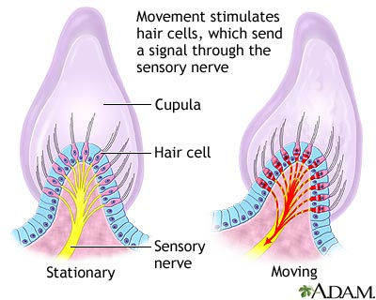  •Equilibrium  - –Mechanoreceptors in the semicircular canals detect  _______________ and movement of the head  - –Little ______________ send information to the  brain to cause appropriate motor output so as to correct position when it is unbalanced.  - –Vertigo (dizziness)  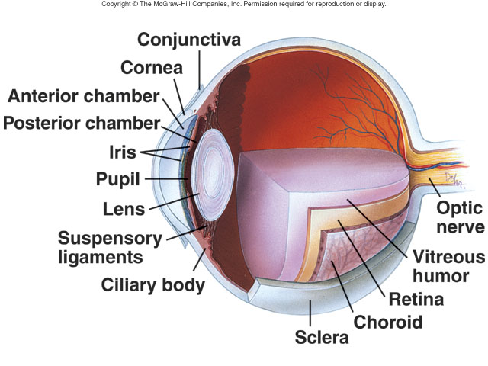  •Sense of Sight  - Anatomy of the Eye  - ______________ – protection (white of eye)  - ______________ – refracts light  - _____________________ – maintains eyeball shape  - _________________ – back layer of photoreceptors in eye  - _________ – black & white vision  - _________ – color vision  - _________________ – sends impulses to brain  - _________ – focuses light  - ________________ – holds lens in place, accommodation  - _________ – regulates light entrance (muscle)  - ___________– admits light  •How we see  –1. Light enters through the ___________.  •The pupil can _____________ or _____________ to allow different amounts of light into the eye.  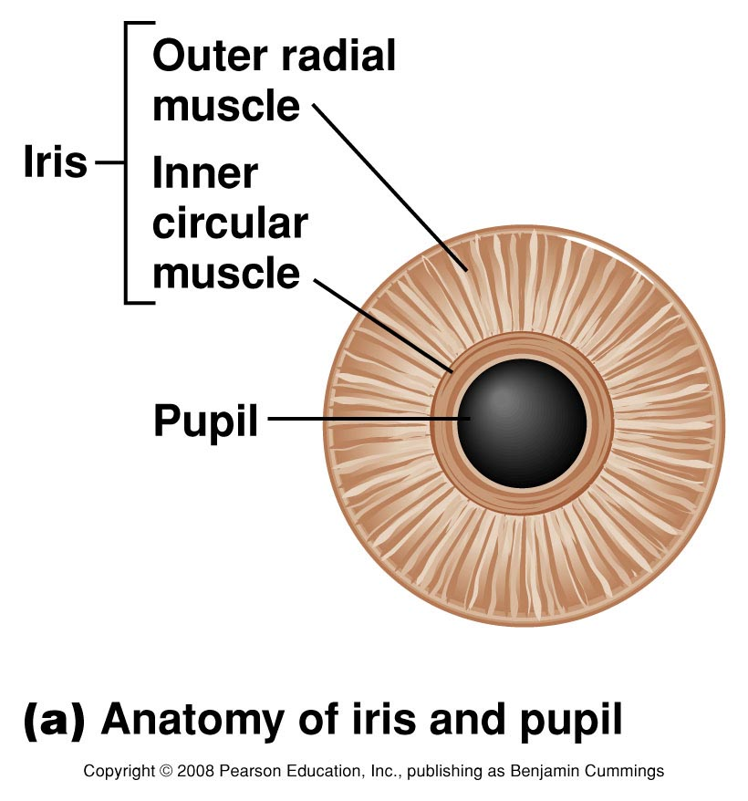  –2. Light passes through the __________ and vitreous humor to the back of the  eye, the retina.  •The lens can change shape to focus light through ___________________.  •Object is far the lens _______________  •Object is near the lens ______________  •The image projected from the lens on the back of the eye is upside down.  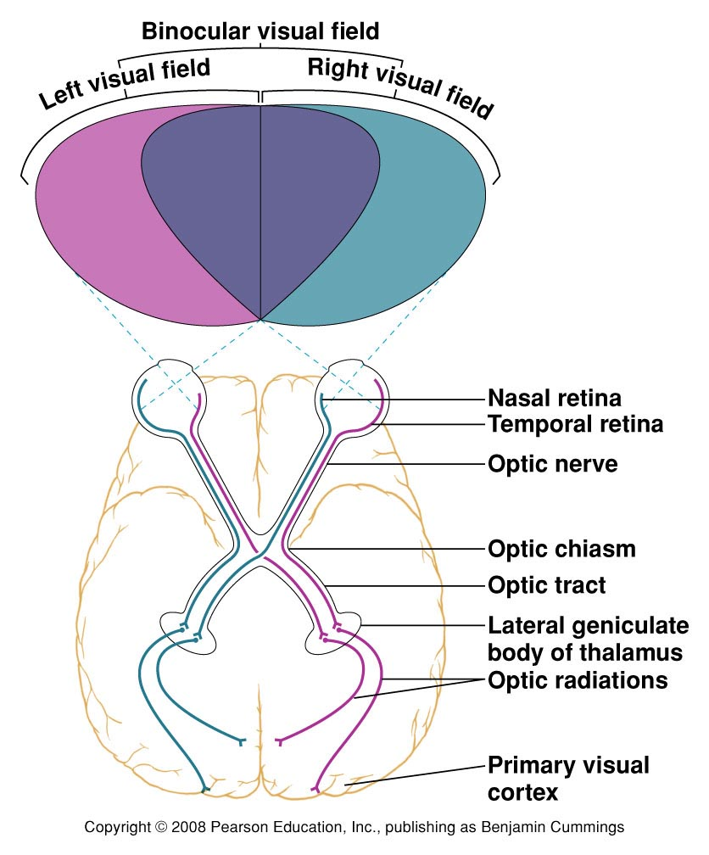  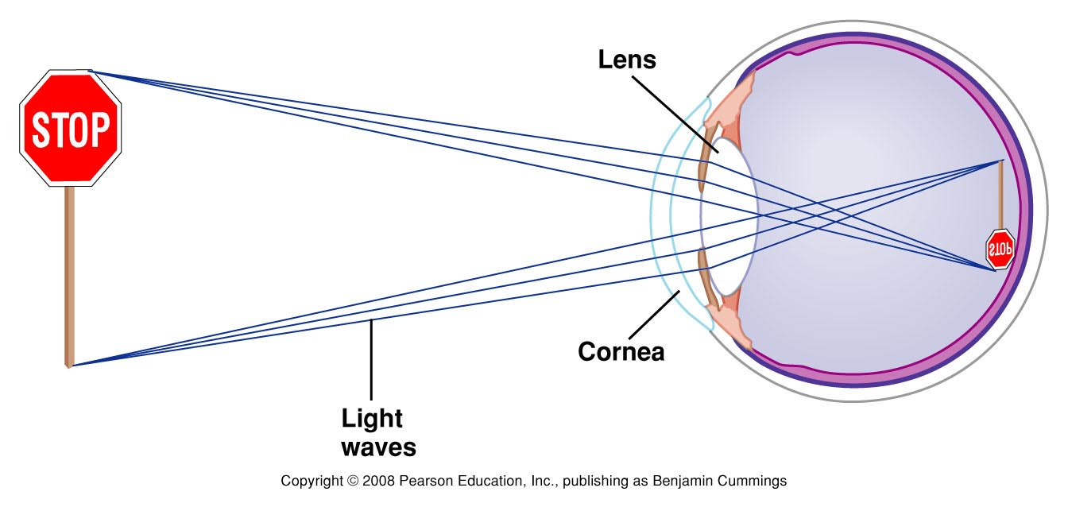  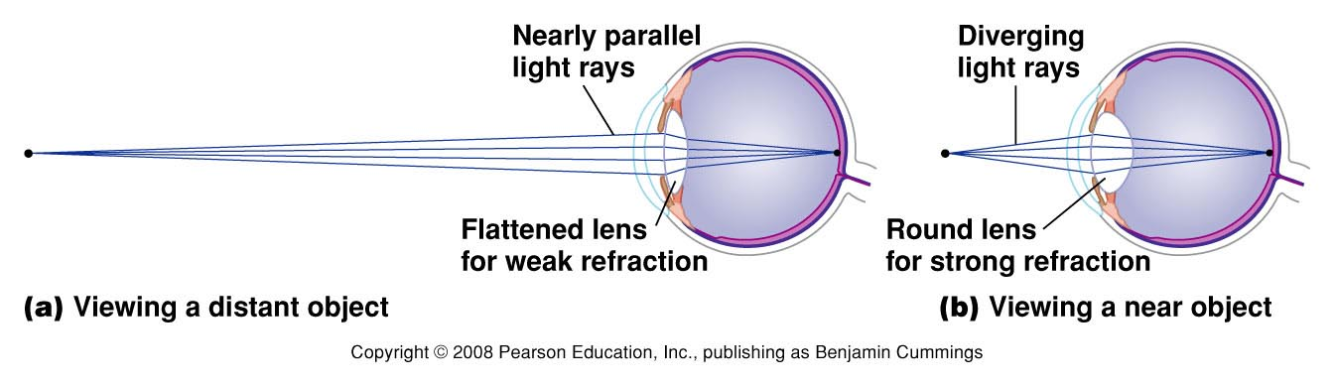  –3. The retina has __________________ cells  that detect light and send impulses to the brain.  •________ – __________________ vision  – sensitive to light; night vision  •_________– ______________ & detail  –Sensitive to bright light  –Blue, green, and red pigment cones detect different wavelengths of  light  –4. Impulses from the rods and cones in the retina are  sent to the ___________________  •This spot on the retina has not rods or cones and creates a ________________  –5. The optic nerves from each eye cross at the  ___________________.  •Input from the right eye goes to the left occipital lobe  •Input from the left eye goes to the right occipital lobe  –6. Visual integration centers in the occipital lobe  process visual input.  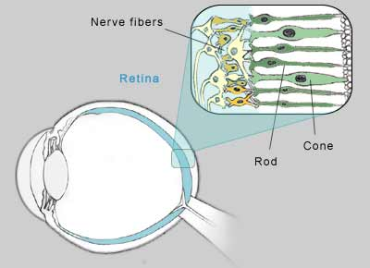  •Vision Disorders  •Farsightedness: trouble seeing __________  –eye too short and/or lens too weak  –light focuses behind retinal  –correct with “convex” lens to add power  •Nearsightedness: trouble seeing far ______  –eye is too long and/or lens is too powerful  –light focuses in front of retina  –correct with “concave” lens to reduce power  •Presbyopia: ___________________  •The crystalline lens tends to harden with age  •The near point of distinct vision moves further and further away from the eye with age.  •Astigmatism  •Abnormal curvature of the cornea  •Light from vertical and horizontal  direction do not focuses in the same  point  •Correct with “cylindrical” lens to  compensate  •Color Blindness  •Red-green color-blindness – occurs when red or green cones or pigments are missing  –Due to sex-linked gene (on X chromosomes) so more common in men.  •Non-sex-linked condition  –Blue-color blindness- missing blue cones or pigments  –Monochromats: people who are totally colorblind, more severe  •Disorders of the Eye  •Glaucoma  –Damage to the optic nerve occurs due to increased eye pressure  –Can lead to blindness  •Cataracts  –Clouding of the lens that affects vision  –Very common in older people  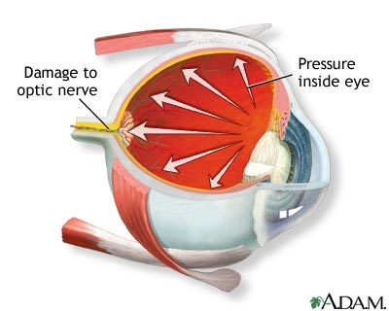  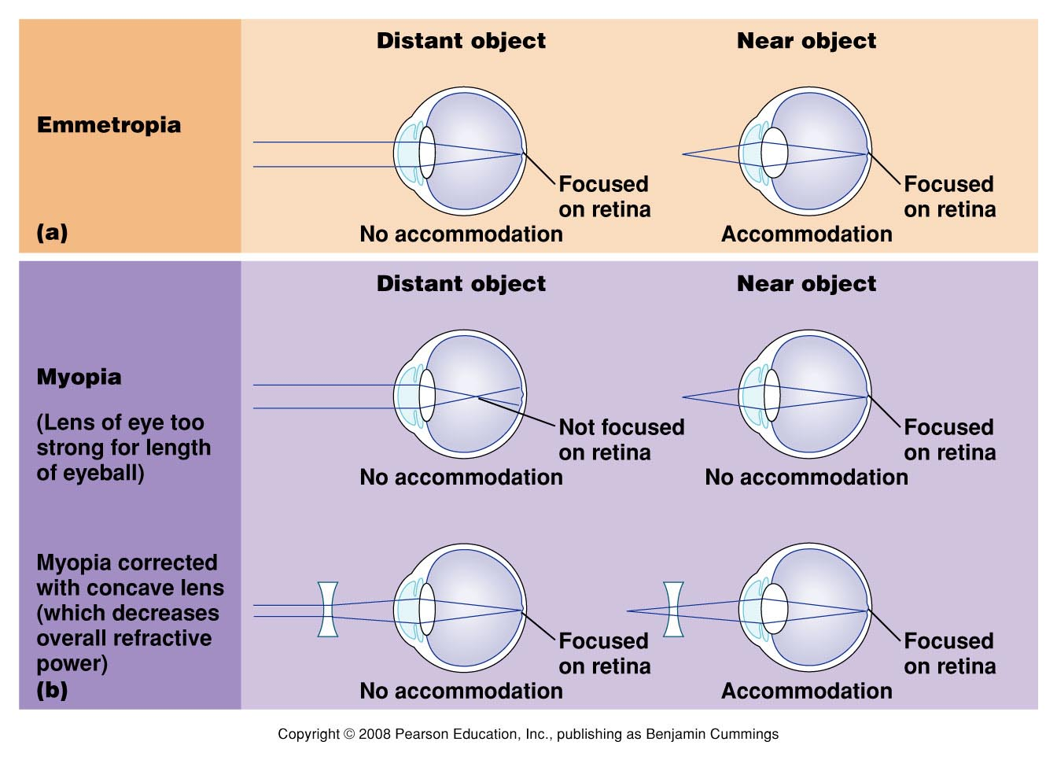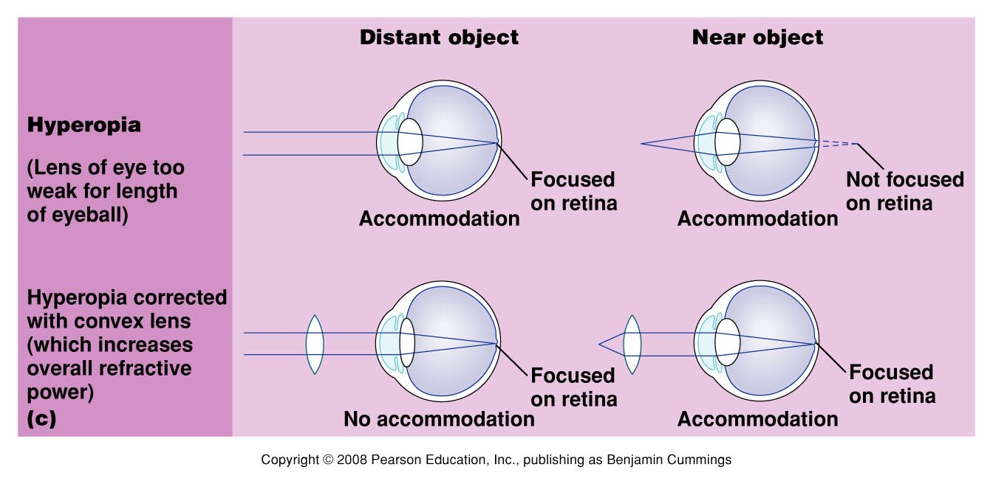  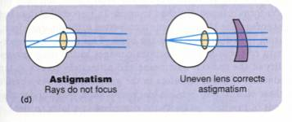
Learning Goals
- Describe the 5 types of sensory receptors and where they are found.
- Describe the two chemical senses.
- Explain how we hear.
- Explain how we see.

