The Integumentary System

(The most underappreciated System)

To be an active learner insures you activate your brain and take charge of the information you are learning. We will tackle the integumentary system in this fashion. Rather than relying heavily on lectures. We will combine a brief lecture with various learning stations pertaining to the integumentary system.

Day 1 Introduction to the Integumentary System lecture by Ms. Stephens.

Learning Station #1

Skin Poster Session

Create a poster that includes all of the important features of the integumentary system. Be sure to pay close attention to detail, include labels, and use colors.

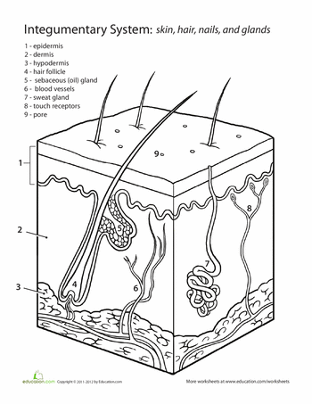

Learning Station #2

Integumentary System Power Point

Working in a group of three, create a brief Power Point presentation covering one of the following aspects of the integumentary system:

• Skin Cancer • Psoriasis

• The Rule of Nines

• ABCDE rules of moles

• Epidermis & Dermis

• Viral Infections • Bacterial Infections

• Sebaceous & Sudoriferous Glands

• Sun Burns & Sun Tans

• 1st , 2nd , 3rd Degree Burns

Slide # 1:

Title, definition, include a picture, and your names

Slide #2:

Scientific Facts with pictures or charts, Use simple bulleted or Numbered sentences, don’t type a paragraph! Maximum 3 short sentences/page.

Slide #3: What is the Cause? (If applicable)

Slide #4: How does it Spread? (If applicable)

Slide #5: How does this make a person uncomfortable?

Slide #6: What is a remedy?

Slide #7: How can it be prevented?

Slide #8:

Summary: ~Include reference information ~Keep backgrounds & fonts simple –(Less is more…) ~If your topic is not a disorder, create a presentation that highlights the major aspects of your topic (i.e. – what type of cells comprise the epidermis, etc.)

\*\*Your power point presentations must be ready to present to the class on October 31/Nov. 1

Learning Station #3:

Microscopic Investigation

Individually, examine the following slides:

• Thick skin • Thin Skin • Human Scalp

Create a detailed drawing of each of the aforementioned slides. Include all pertinent features (dermis, each layer of the epidermis, glands, hair, arrector pili muscle, etc.) – Again, refer to your textbook for guidance. A separate lab handout will be available.

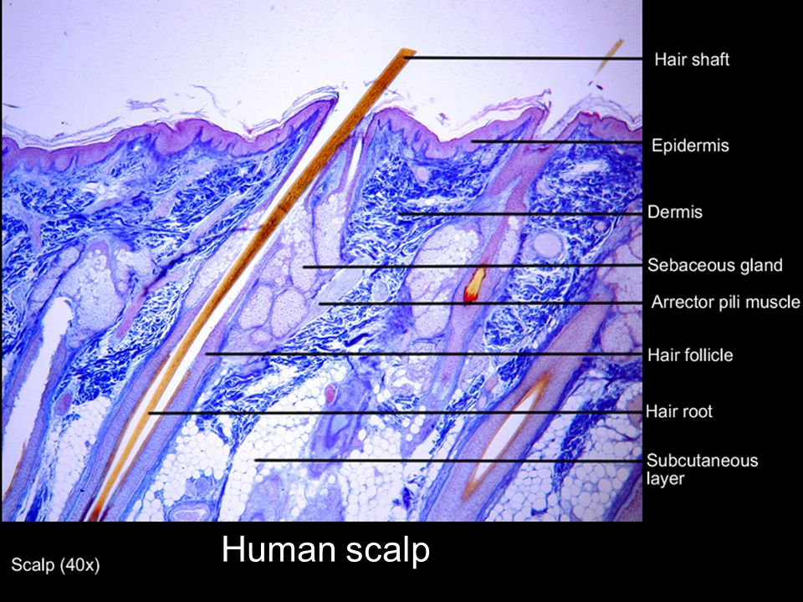



Learning Station #4:

“Did you know..?”

Throughout this unit, research and collect interesting facts about the integumentary system. Type up the fact, include your name & reference source & post your fact on the file cabinet by the star charts. On test day, extra credit will be given to the most interesting fact. You are expected to contribute at least one fact over the course of the unit.

Learning Station #5:

Model Behavior: Quiz grade

Examine the models provided of the skin. Correctly identify each structure by number & provide that structure’s function.

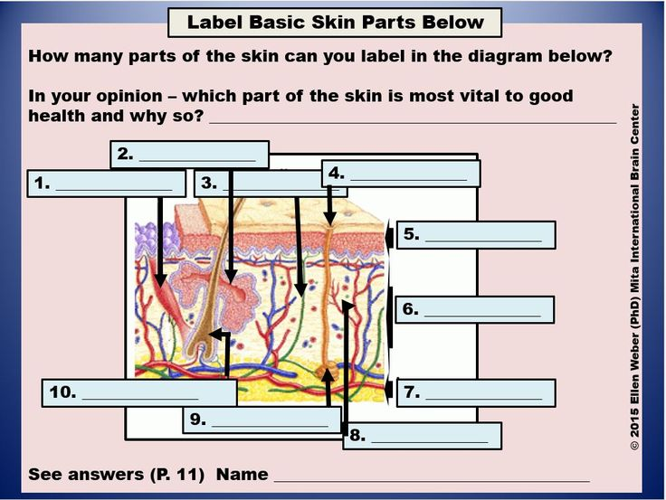

Learning Station #6

Coffee Talk

Have you ever visited Starbucks or similar coffee establishment and looked around? Notice how many people are enjoying a cup of Joe while carrying out stimulating conversations? (I’m not encouraging eavesdropping…) Here’s your opportunity to sit down with your peers and discuss topics regarding the integumentary system over a cup a steaming something-or-other. Yes – bring in some tea, coffee, cocoa, etc & sit down and have a stimulating, intellectual conversation about the integumentary system. Your assignment is to research a topic regarding this system, find an article or scientific paper & then be ready to discuss it over a cup of hot beverage on October 31, 2016 or November 1, 2016. In order to receive full credit, you must correctly cite your article on your summary worksheet/review rubric on the assigned Coffee Talk Day & actively discuss your paper with your peers.

Learning Station #7:

Final Summative Assessment: Wednesday/Thursday November 4/7, 2016.

This exam will be similar to the histology exam; there will be both written and lab practical portions. Expect microscope slides, models, and diagrams to appear on the lab practical.

Review for the final assessment by completing (questions 1-10) this concept map of the Integumentary system and the associated Endocrine glands.



3. Name and describe the function of the three accessory structures.

2. Name and describe the 3 layers of skin.

1. Explain the function of the integumentary system.



10. Mammary glands are what type of specialized gland?

9. How is ear wax made?

8. Compare and contrast the location and function of apocrine sweat glands and merocrine sweat glands.

7. What is the difference between a typical sebaceous gland and a sebaceous follicle?

6. Name the function of sweat glands.

5. Describe the job of the sebaceous glands.

4. What are the primary functions of the Endocrine glands?