Integumentary System Name:______________
Part 2: Skin Disorders
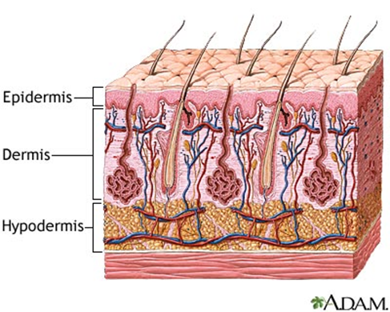
Unit 3: Integumentary System A&P Chapter 5
Skin Disorders
1. Chronic Disorders
2. Infectious Disorders
3. Burns
4. Skin Cancers
I. Chronic Skin Disorders
_____________________
Raised, often itchy, _______________________________________
Usually __________________________ (to animal dander, insect bites, pollen, shellfish, nuts, eggs, milk)
Also caused by stress, extreme cold or hot, or illness
________________
__________________________________________________
Dry, flaky, blistering skin appears red and inflamed
Intense itching and burning sensations
____________________________________________to chemicals, fabrics, heat, dryness
______________________________________
Caused by a yeast
_______________________________________________
Often found on the _______________________
Not contagious
Psoraiasis
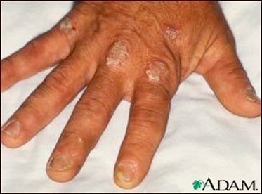
____________________________________________
Redness and irritation
Genetic
The body produces too many new skin cells.
Normally skin cell turn around is ~30 days, but with psoraiasis, turn over is around one week.
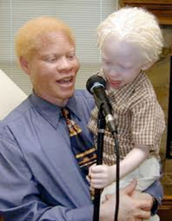
____________________
Genetic disorder in which the __________________________
Symptoms: _________________________ in hair, skin, or iris; light sensitivity; prone to sunburn & skin cancer

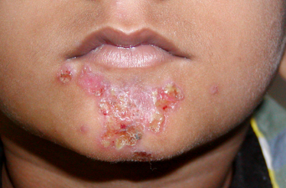
II. Infectious Skin Disorders
_________________
  - ________________________________
  - Highly contagious
  - Causes ____________________ on face and hands
  - Common among kids
Acne
- Caused by an __________________________________, leading to clogging of the pores
- _____________________________, dead skin cells, and pus (white blood cells)
- ___________________________________________ form red bumps
- Pimples deep in the skin can form painful _____________________________
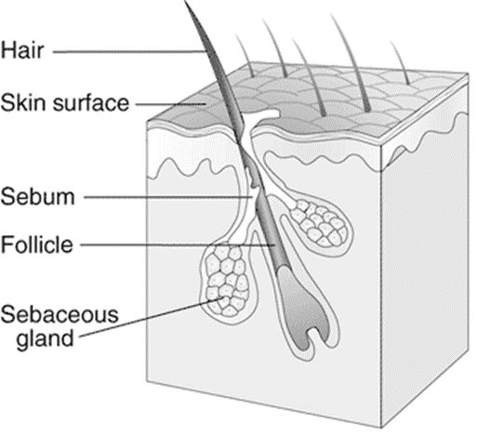
  - Normal hair follicle
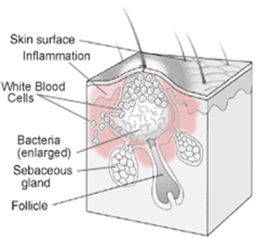
Acne
Other causes of acne
  - ____________________
  - ____________________ due to menstrual cycles (females) or stress
  - ________________________________________________________
  - ___________________________ (such as steroids, testosterone, estrogen)
  - High levels of humidity and ___________________________________
  - Diets high in refined _____________________________________________
Athlete’s Foot
__________________________________
- Very common on foot or other _________________________________________
- Fungus infects the upper layers of the skin, causing __________________________________
Ringworm
  - Not a worm, _________________________________________
  - _______________________________________ with frequent wetness (such as from sweating) and minor injuries to your skin
  - ____________________________________ that may blister and ooze
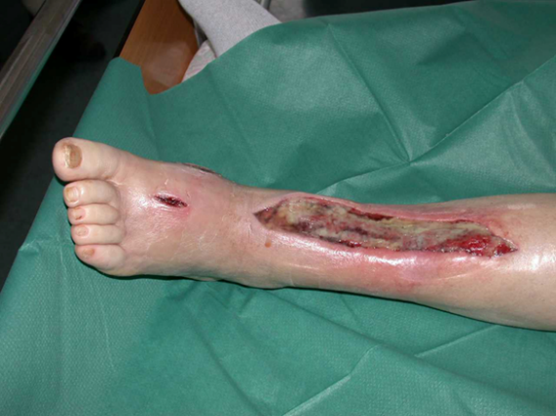
______________________________
- “Flesh-eating disease”
- ________________________________
- _________________________________
- ________________________________
MRSA (Methicillin-Resistant
Staphylococcus aureus)
- Staph infections are __________________________________
- Staphylococcus bacteria normally lives on the skin with no problems
- __________________________________________________and therefore very dangerous or deadly
Signs & Symptoms MRSA
- _________________________________________________________________________________
- Staph skin infections start as ________________________________ that resemble pimples, boils or spider bites
- Quickly turn into _____________________________________ that must be surgically drained
- Sometimes the bacteria remain in the skin, but if it penetrates into the body, it ________________________________________________________
III. Skin Burns
- A burn is tissue damage which __________________________________________ in the affected areas
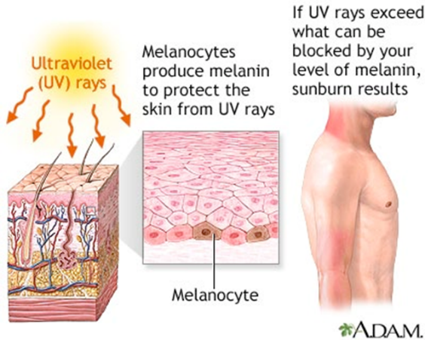
- Caused by:
  - ___________________
  - ________________________ (sunlight, tanning beds)
  - _________________________
  - _________________________
Degrees of Burns
- _________________________
  - Burns only the epidermis (ex. Sunburn)
  - Redness & Pain, no blistering
- Are Tanning Beds Safer?
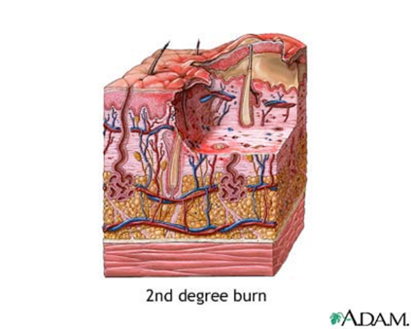
- The salons say yes, but studies show tanning beds still increase the risk of cancer
______________________________
- Burns occur in the epidermis and some of the dermis
- Redness, Pain, & blistering
_____________________________________
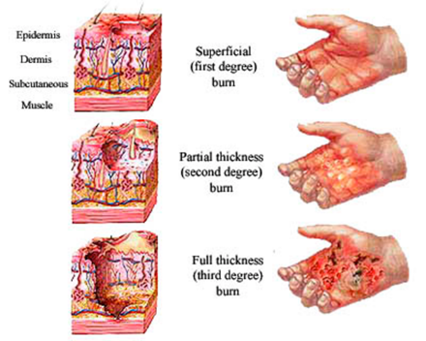
- The epidermis, dermis, and hypodermis are destroyed
- Damage to the nerve endings (ex. Exposure to direct fire)
- http://video.about.com/firstaid/Burns
Extent of Burns
- __________________________________
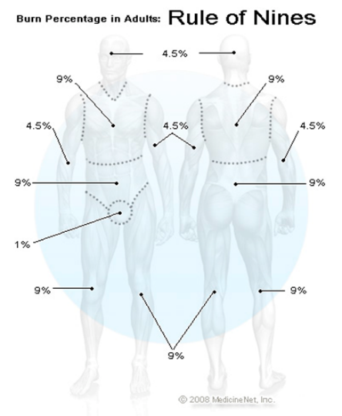
  - Body is divided into 11 regions (each accounting for 9% of total body area)
- Critical Burns
_______________________________________
  - Burns on __________________________,
or completely encircling
the ________________________________
Treatment of Critical Burns
- Complications:
  - __________________________________________
- Intense doses of intravenous fluids to replace electrolyte imbalance
- Warm and isolated environment to reduce risk of infection
- _____________________ can be done as soon as patient is stable
IV. Skin Cancer
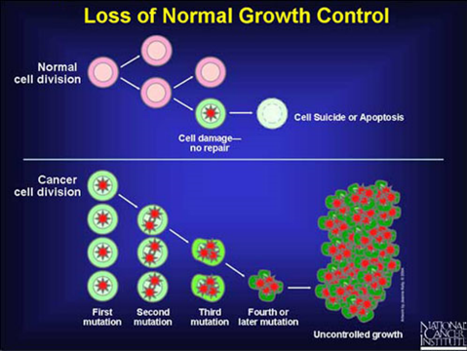
- Risk Factors
  - _________________________ (Older people)
  - __________________________
  - _____________________________
  - __________________________ (family history)
  - Chemical exposure
- When to see your doctor:
  - If you have any of the warning signs, are older, or have a family history of skin cancer

Cancer Vocabulary
- _____________________– abnormal division of a cell that has undergone a DNA mutation
  - _________________________ – mass of mutated cells
- ______________________________- the spread of cancer cells from one part of the body to another
- Two Categories of Skin Cancer:
  - 1) Non-Melanoma
    - Includes Basal cell carcinoma and Squamous cell carcinoma
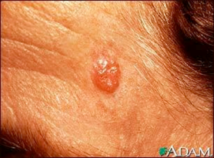
  - 2) Melanoma
Basal Cell Carcinoma
- ___________________________________________________
- Occurs – in sun-exposed areas
- ________________________ – pearly or ______________________ or a flat, flesh-colored or brown ______________________________________
- ____________________________– cryosurgery, surgical removal
  - 95% of patients easily cured,
but it may come back
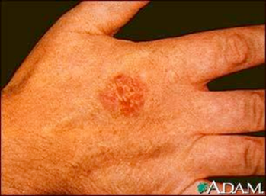
Squamous Cell Carcinoma
- Five times less common than basal cell carcinoma, but more likely to spread to nearby organs
- ______________________ – on sun-exposed areas
- Appearance – firm, ________________________ or a flat lesion with a ________________________________
- Treatment – cryosurgery,
surgical removal,
medication
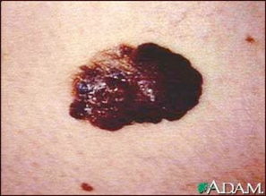
Melanoma
- _________________________________________________
- Occurs – anywhere on body’s skin
- Appearance – large _________________________________ with darker speckles or a mole that changes in color, size or bleeds
  - Men – on trunk, head or neck
  - Women – lower legs
- Treatment – surgical removal, radiation, chemotherapy

Learning Goal Questions
1) Explain why acne occurs, including its causes.
2) Describe MRSA and predict why people in hospitals are susceptible.
3) Compare and contrast the 3 degrees of skin burns, including what layer of skin is affected and the potential complications of burns.
4) Describe the risk factors for skin cancer and compare and contrast the 3 types of skin cancer.

Ticket in the Door
Describe the risk factors for skin cancer and compare and contrast the 3 types of skin cancer.
- Do NOT Write on Article.
- Read “A Case Study on Homeostasis-Hyperthermia”
- Answer questions from the back page.

Ticket out the Door
- 1) Explain why acne occurs, including its causes.
- 2) Describe MRSA and predict why people in hospitals are susceptible.
- 3) Compare and contrast the 3 degrees of skin burns, including what layer of skin is affected and the potential complications of burns.

Ticket in the Door Pt1ppt
- Describe the 3 layers of skin.
- Explain the 5 functions of skin.

